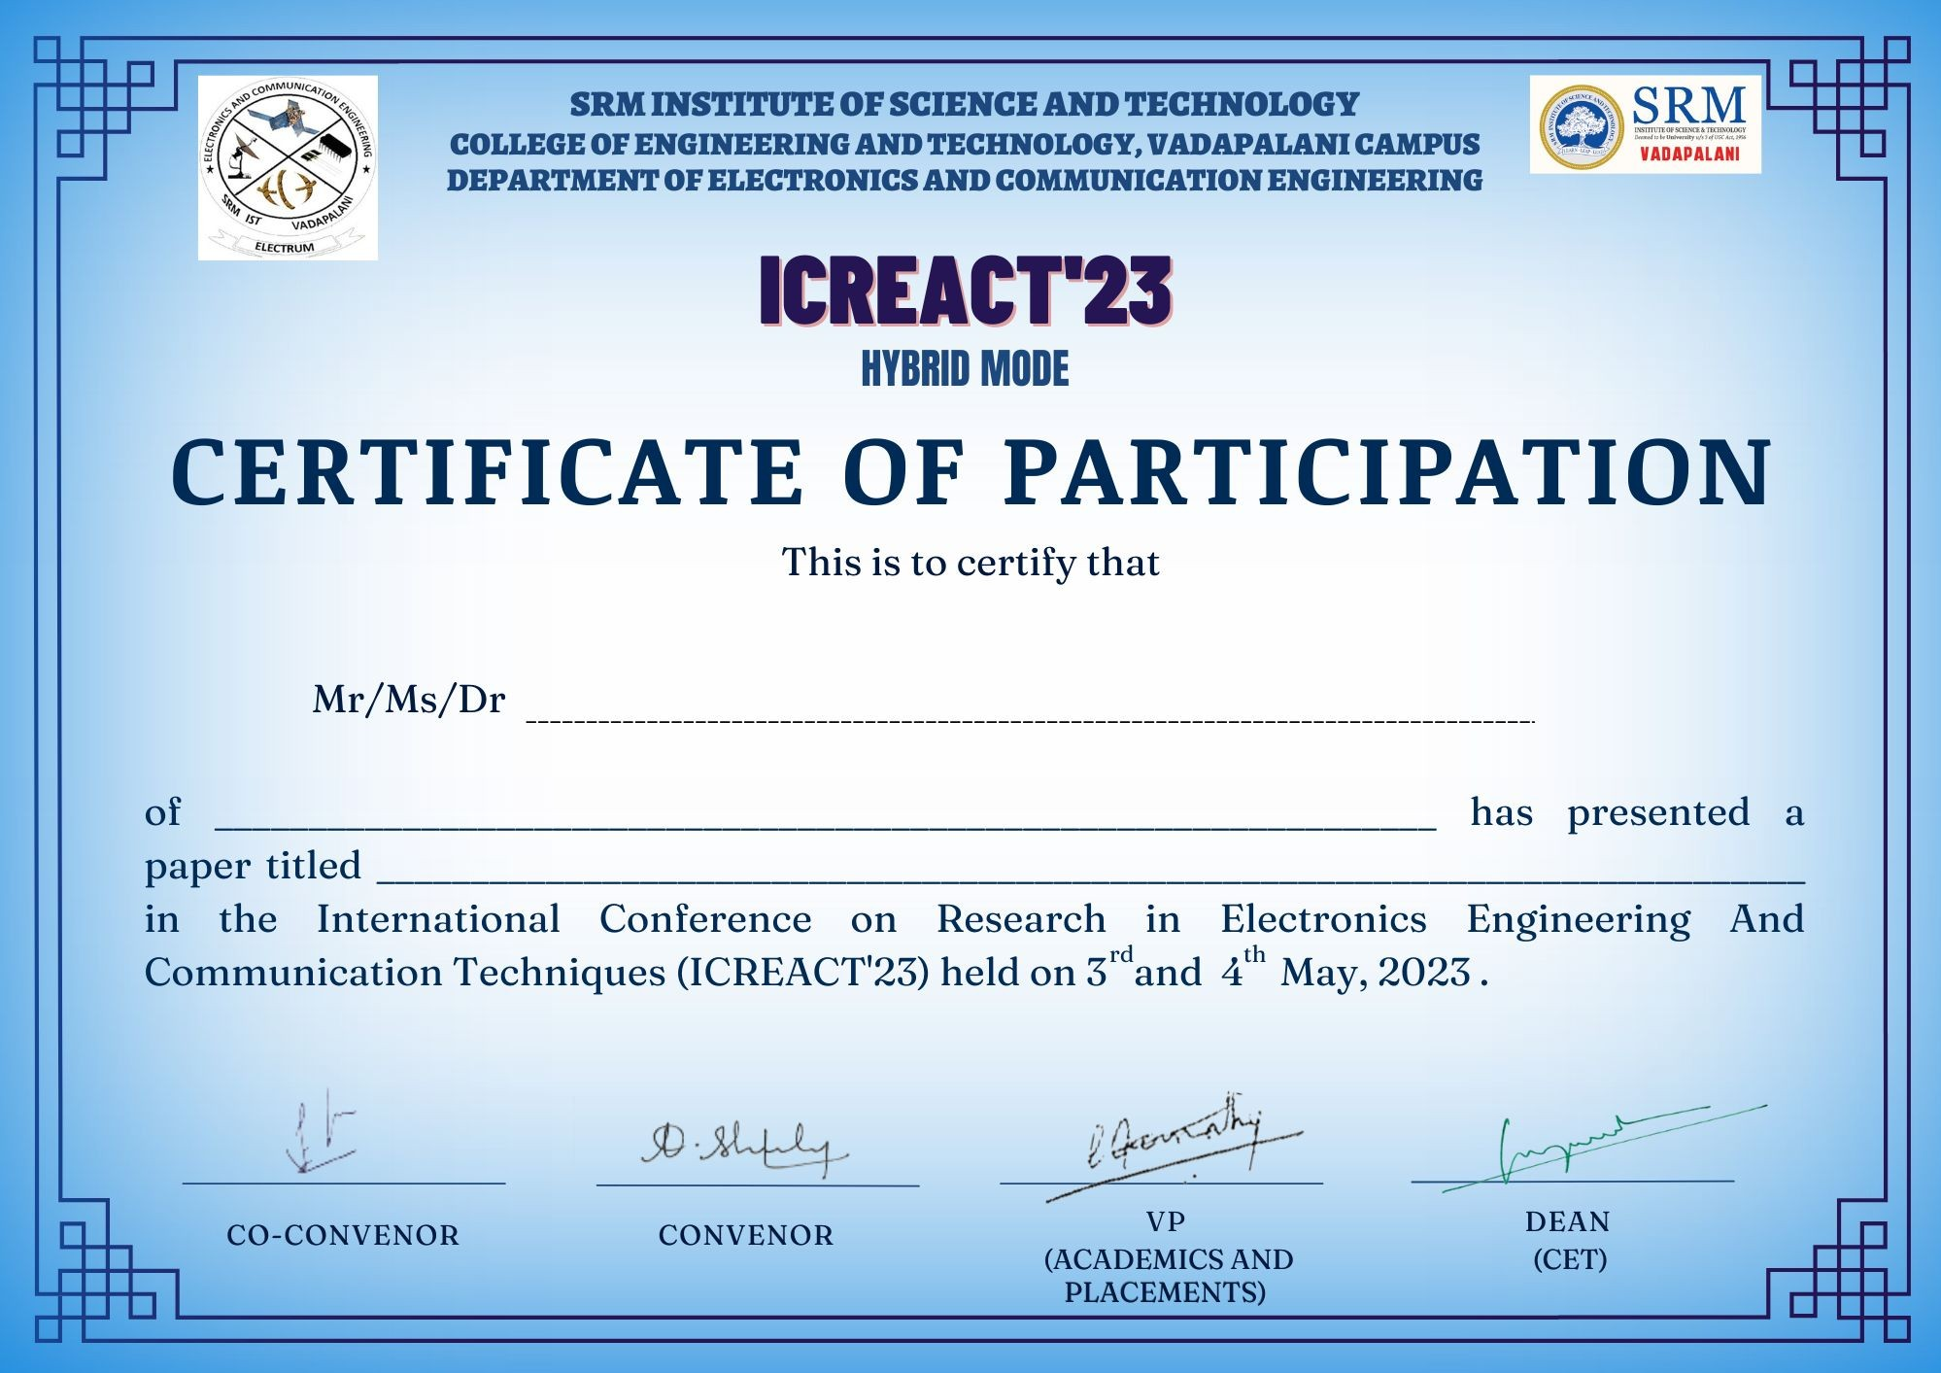

ICREACT23273

Rajesh R

SRM Institute Of Science And Technology vadapalani

Te t to braillie communication device